The turn order
The turn order is determined by random card draw, shuffled at the end of each round, until only 3 players remain, who will then roll for initiative every round. Last monster standing wins.
On your turn, you will activate each of your creatures, one after the other. Each creature may take:
- a Full round action
or
a Standard action and a Move action;
- a Swift action; and
- any number of Free actions.
All available actions are listed on your character sheet.

The Imperative
When activating, each creature must at least take:
- a Full round action;
- a Standard action; or
- a Swift action

Movement, the grid, and the map
Each square on the map counts as 1 point of movement and 1 range, both orthogonal and diagonal, regardless of size.

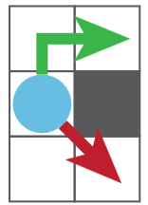
Terrain
- Moving through difficult terrain and statues, or squeezing through spaces smaller than your creature’s base, costs double.
- You cannot move above or cut the corner of a wall, and you cannot end your movement squeezing or on a statue.
- Enemy creatures block movement; friendly creatures do not.

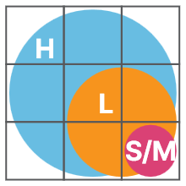
Size
- Small and medium creatures occupy 1 square.
- Large creatures occupy 4 squares: a 2x2 area.
- Huge creatures occupy 9 squares: a 3x3 area.

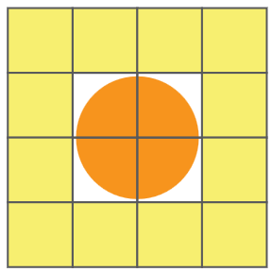
Who you threaten
You only threaten adjacent creatures that have no cover from you, regardless of the range on your melee attacks.
- Moving while threatened will provoke an attack of opportunity (melee attack), once per creature per turn.


How to make melee and ranged attacks
Roll 1d20 and add your hit bonus. If your attack roll meets or exceeds the target’s Armor Class (AC), the attack succeeds.
- All attacks require you to have line of sight to your target.
- Rolling a 1 is a critical miss; rolling a 20 is a critical hit that deals double damage.
- When making multiple attacks, you may make the attacks in any order, and may target different creatures with each attack.

Benefits of combat advantage
You have combat advantage and gain +2 to hit against:
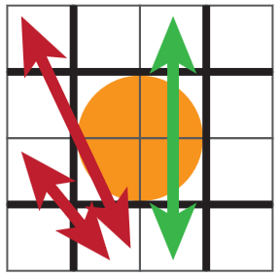
- creatures that are blinded, grappled, constricted, paralyzed, squeezed, or stunned;
- creatures that cannot see you; and
- creatures that you are flanking.
To flank, you and another creature must be adjacent and on opposite sides or corners to your target.

Determining line of sight
You have line of sight if you can draw a straight line from any one of your corners through any of your target’s squares.
- Only walls block line of sight.

Benefits of cover
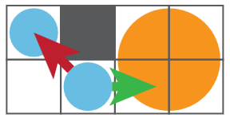
You gain +4 AC and are not threatened by a creature when you have cover from them.
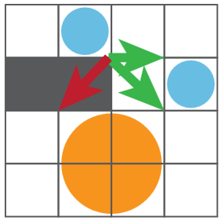
- Against attacks with a maximum range
of 1, you have cover when your closest occupied square cuts diagonally across a wall or statue from the attacker’s closest occupied square.
- Against attacks with a maximum range
of 2 or more, you have cover when the attacker cannot see all 4 of your corners from any one of its corners.

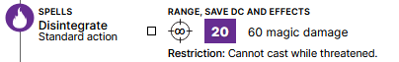
Casting spells and using special abilities
Spells and special abilities do not require attack rolls.
- All spells and special abilities require you to have line of sight to your target and, if it has an area of effect, to a creature in the area of effect.
- Some have limited uses, indicated with boxes.
- Some require the target to make a save against a Difficulty Class (DC). They roll 1d20 and add their Save bonus (Saves). If the total meets or exceeds the DC, the save is successful, reducing damage by half and nullifying other effects.
  - Rolling a 1 is an automatic failure; rolling a 20 Is an automatic save.
- If a creature has spell resistance, you must overcome it to affect that creature with a spell. This has no effect on special abilities and melee and ranged attacks.
  - Roll 1d20. If your roll meets or exceeds the target’s spell resistance, the spell is successful.

Areas of effect
All creatures within an area of effect with line of sight to the target or origin square are affected by the spell or special ability.
- Burst 3 covers a 7x7 area centered on a target square.
- Blast 5 covers a 5x5 area adjacent to your creature.
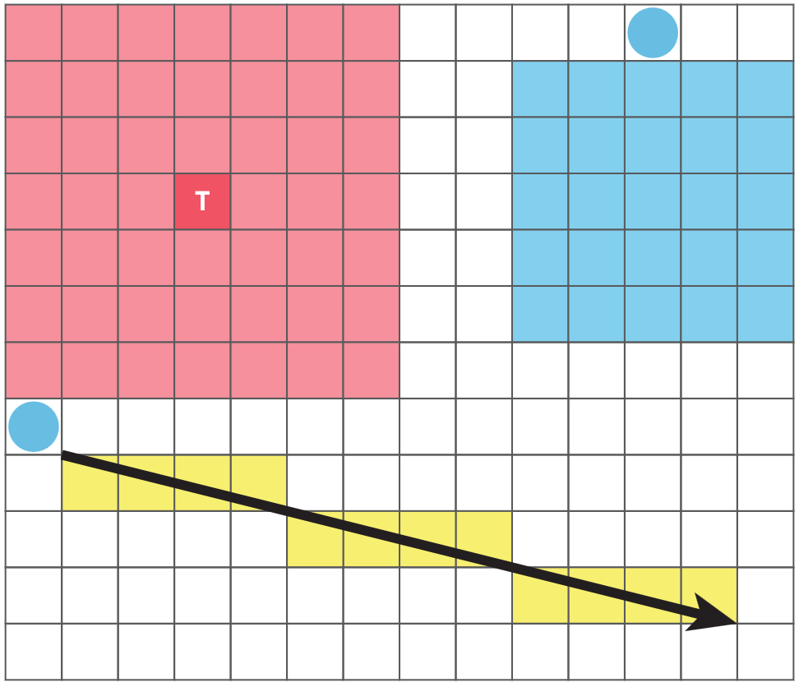
- Line 12 covers all squares and corners on a line starting from of your corners and extending 12 squares away.

